Percentile Report:

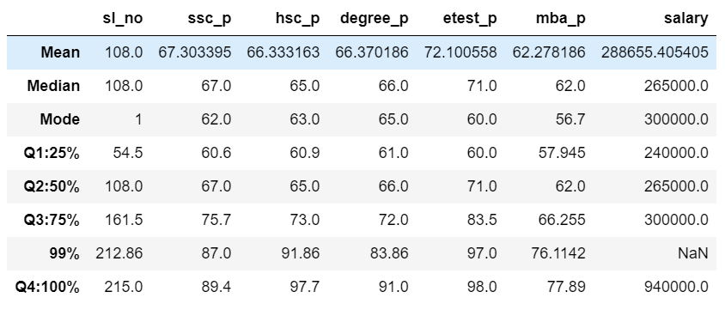

**Percentile of ssc_p:**

* The 25th percentile score is 60.6
* The 50th percentile score is 67.0

The difference between 25th and 50th percentile is 25%, the students mark percentage is increased by 7%

* The 75th percentile score is 75.7

The difference between 50th and 75th percentile is 25%, the students mark percentage is increased by 8%

* The 99th percentile score is 87.0

The difference between 75th and 99th percentile is 25%, the students mark percentage is increased by 12%

* The 100th percentile score is 89.4

The (highest range) last difference between 99th and 100th percentile is 1%, the students mark percentage is increased by 2%

**Percentile of hsc_p:**

* The 25th percentile score is 60.9
* The 50th percentile score is 65.0

The difference between 25th and 50th percentile is 25%, the students mark percentage is increased by 5%.

* The 75th percentile score is 73.0

The difference between 50th and 75th percentile is 25%, the students mark percentage is increased by 8%.

* The 99th percentile score is 91.86

The difference between 75th and 99th percentile is 25%, the students mark percentage is increased by 18%.

* The 100th percentile score is 97.7

The (highest range) last difference between 99th and 100th percentile is 1%, the students mark percentage is increased by 6%.

**Percentile of degree_p:**

* The 25th percentile score is 61.0
* The 50th percentile score is 66.0

The difference between 25th and 50th percentile is 25%, the students mark percentage is increased by 5%.

* The 75th percentile score is 72.0

The difference between 50th and 75th percentile is 25%, the students mark percentage is increased by 6%.

* The 99th percentile score is 83.86

The difference between 75th and 99th percentile is 25%, the students mark percentage is increased by 11%.

* The 100th percentile score is 91.0

The (highest range) last difference between 99th and 100th percentile is 1%, the students mark percentage is increased by 8%.

**Percentile of etest_p:**

* The 25th percentile score is 60.0
* The 50th percentile score is 71.0

The difference between 25th and 50th percentile is 25%, the students mark percentage is increased by 11%.

* The 75th percentile score is 83.5

The difference between 50th and 75th percentile is 25%, the students mark percentage is increased by 12%.

* The 99th percentile score is 97.0

The difference between 75th and 99th percentile is 25%, the students mark percentage is increased by 14%.

* The 100th percentile score is 98.0

The (highest range) last difference between 99th and 100th percentile is 1%, the students mark percentage is increased by 1%.

**Percentile of mba_p:**

* The 25th percentile score is 57.945
* The 50th percentile score is 62.0

The difference between 25th and 50th percentile is 25%, the students mark percentage is increased by 5%.

* The 75th percentile score is 66.255

The difference between 50th and 75th percentile is 25%, the students mark percentage is increased by 4%.

* The 99th percentile score is 76.1142

The difference between 75th and 99th percentile is 25%, the students mark percentage is increased by 10%.

* The 100th percentile score is 77.89

The (highest range) last difference between 99th and 100th percentile is 1%, the students mark percentage is increased by 1%.